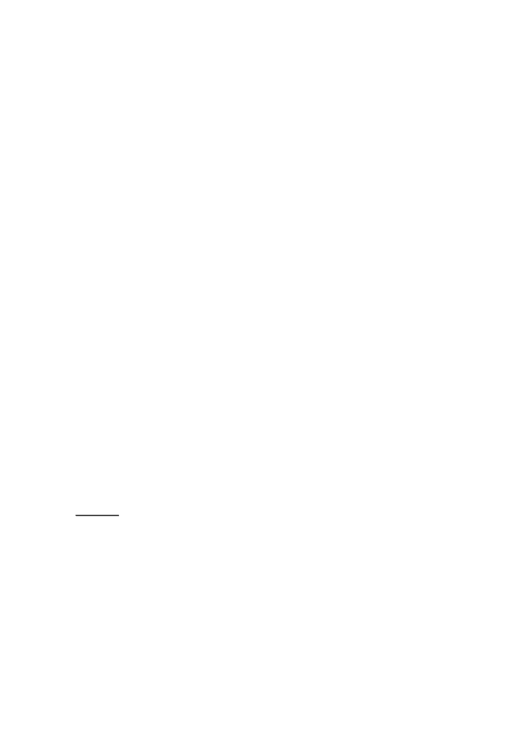

3.4 Switch
The switch statement is a multi-way decision that tests whether an expression matches one of a number of constant integer values, and branches accordingly.
switch (expression) {
case const-expr: statements
case const-expr: statements
default: statements
}
Each case is labeled by one or more integer-valued constants or constant expressions. If a case matches the expression value, execution starts at that case. All case expressions must be different. The case labeled default is executed if none of the other cases are satisfied. A default is optional; if it isn'tthere and if none of the cases match, no action at all takes place. Cases and the default clause can occur in any order.
In Chapter 1 we wrote a program to count the occurrences of each digit, white space, and all other characters, using a sequence of if ... else if ... else. Here is the same program with a switch:

#include <stdio.h>
main() /* count digits, white space, others */
{
int c, i, nwhite, nother, ndigit[10];
nwhite = nother = 0;
for (i = 0; i < 10; i++)
ndigit[i] = 0;
while ((c = getchar()) != EOF) {
switch (c) {
case '0': case '1': case '2': case '3': case '4': case '5': case '6': case '7': case '8': case '9':
ndigit[c-'0']++;
break;

As a matter of good form, put a break after the last case (the default here) even though it'

53
case ' ':
case '\n':
case '\t':
nwhite++;
break;
default:
nother++;
break;
}
}
printf("digits =");
for (i = 0; i < 10; i++)
printf(" %d", ndigit[i]);
printf(", white space = %d, other = %d\n",
nwhite, nother);
return 0;
}
The break statement causes an immediate exit from the switch. Because cases serve just as labels, after the code for one case is done, execution falls through to the next unless you take explicit action to escape. break and return are the most common ways to leave a switch. A break statement can also be used to force an immediate exit from while, for, and do loops, as will be discussed later in this chapter.
Falling through cases is a mixed blessing. On the positive side, it allows several cases to be attached to a single action, as with the digits in this example. But it also implies that normally each case must end with a break to prevent falling through to the next. Falling through from one case to another is not robust, being prone to disintegration when the program is modified. With the exception of multiple labels for a single computation, fall-throughs should be used sparingly, and commented.
s
logically unnecessary. Some day when another case gets added at the end, this bit of defensive programming will save you.
Exercise 3-2. Write a function escape(s,t) that converts characters like newline and tab
into visible escape sequences like \n and \t as it copies the string t to s. Use a switch. Write
a function for the other direction as well, converting escape sequences into the real
characters.
3.5 Loops - While and For
We have already encountered the while and for loops. In
while (expression)
statement
the expression is evaluated. If it is non-zero, statement is executed and expression is reevaluated. This cycle continues until expression becomes zero, at which point execution resumes after statement.
The for statement

for (expr₁; expr₂; expr₃)
statement
is equivalent to
expr₁;
while (expr₂) {
statement
expr₃;
}
except for the behaviour of continue, which is described in Section 3.7.

is an `
`infinite'

54
Grammatically, the three components of a for loop are expressions. Most commonly, expr1 and expr3 are assignments or function calls and expr2 is a relational expression. Any of the three parts can be omitted, although the semicolons must remain. If expr1 or expr3 is omitted, it is simply dropped from the expansion. If the test, expr2, is not present, it is taken as permanently true, so

for (;;) {
}
'loop, presumably to be broken by other means, such as a break or return.
Whether to use while or for is largely a matter of personal preference. For example, in

while ((c = getchar()) == ' ' || c == '\n' || c = '\t')
; /* skip white space characters */
there is no initialization or re-initialization, so the while is most natural.
The for is preferable when there is a simple initialization and increment since it keeps the
loop control statements close together and visible at the top of the loop. This is most obvious
in

for (i = 0; i < n; i++)
which is the C idiom for processing the first n elements of an array, the analog of the Fortran DO loop or the Pascal for. The analogy is not perfect, however, since the index variable i retains its value when the loop terminates for any reason. Because the components of the for are arbitrary expressions, for loops are not restricted to arithmetic progressions. Nonetheless, it is bad style to force unrelated computations into the initialization and increment of a for, which are better reserved for loop control operations.
As a larger example, here is another version of atoi for converting a string to its numeric equivalent. This one is slightly more general than the one in Chapter 2; it copes with optional leading white space and an optional + or - sign. (Chapter 4 shows atof, which does the same conversion for floating-point numbers.)
The structure of the program reflects the form of the input:
skip white space, if any
get sign, if any
get integer part and convert it
Each step does its part, and leaves things in a clean state for the next. The whole process terminates on the first character that could not be part of a number.

#include <ctype.h>
/* atoi: convert s to integer; version 2 */ int atoi(char s[])
{
int i, n, sign;

for (i = 0; isspace(s[i]); i++)
;
sign = (s[i] == '-') ? -1 : 1;
if (s[i] == '+' || s[i] == '-')
i++;
for (n = 0; isdigit(s[i]); i++)
n = 10 * n + (s[i] - '0');
return sign * n;
}
/* skip white space */

/* skip sign */

